 |  | Newsletter | LET YOUR LIGHT SHINE  www.primaryschoolsbarnstaple.co.uk  holywell@ventrus.org.uk
Many other school events and news can be found on our Facebook page - click here

24th February 2023
Holywell is a NO NUT Zone.

Message from Mrs. Lowrey

What an amazing week it has been! We have been incredibly busy returning after half term, but I am very, very impressed with the excellent attitude that we are seeing across the school.
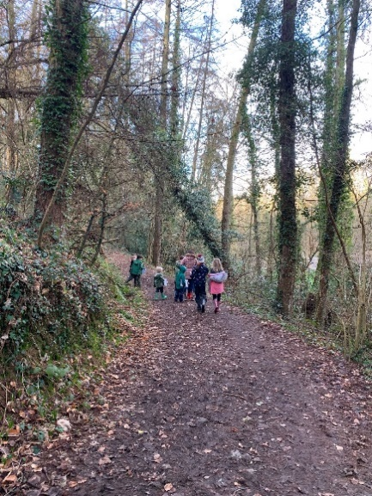
This week, we have been very fortunate to host our first “Welly Walking Club” of the term! The walk was a great success, with children showing great interest in exploring the woods and the nature around them. We are trying to instil in the children a love of being outdoors, enjoying their surroundings and learning together.
Here are some pictures of my fabulous welly walking crew! What excellent behaviour and manners were shown throughout. If you still wish to join our club, please do speak to Mrs Lowrey.
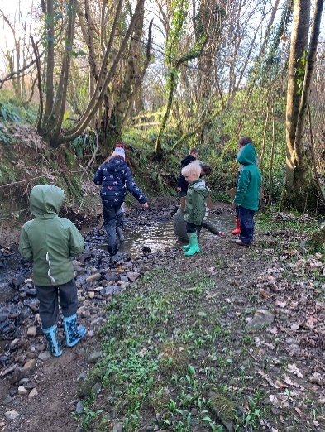
Next week, we are also starting our pottery club! For one week only, this will be held on Thursday 2nd March instead of Monday as Mrs Coulam will be absent on Monday. Please do register for the pottery club if you wish to attend.
We will also be launching some lunchtime clubs this week: Tuesday – KS1 Art club and Friday KS2 Top Trumps Club. I will attach the link below for you to register your child.
Have a wonderful weekend, I hope you do get out and about with your families!

Mrs Lowrey

Lunchtime clubs

Please use the following link to register your child for the following lunchtime clubs:
Tuesday – KS1 Art club – 12.30-1pm
Friday – KS2 Top Trumps club – 12pm-12.30pm

https://forms.office.com/Pages/ResponsePage.aspx?id=3RWFZvuneEGMNLPFLdk_cBxm7KP7e-ZMpJ57Dd1bWclURFI1VDJDRU5PNUtLQ0JVOURPTUpUUU04My4u

Prime and Other Energy Drinks

Parents: Nutritionist advice around Prime and other energy drinks is… The preservatives and artificial sweeteners in Prime’s hydration drinks and the caffeine found in its Prime energy drinks are ingredients that parents should avoid giving to children.
Lucozade Sport is designed for adults who take part in exercise or sport. It contains carbohydrate (i.e. sugars) and electrolytes (i.e. sodium) at levels appropriate for an exercising adult. Children’s requirements of energy and nutrients are different from those of an adult and so Lucozade Sport is not really suitable for children under 16 years.
We therefore ask that: You ensure your child is not bringing Prime or any other energy drink into school for consumption during the school day. The school policy is that your child should have a bottle that contains either water or squash only.
Year 6 children in particular - just removing the label from the bottle does not disguise what is in it!
Can we also please ask that empty Prime bottles are not used as their school water bottle. Just like the issue with Pokemon cards, these bottles are causing fall outs and upsets within peer groups.
Thank you for your support with this matter. If you have any questions around the school’s decision on energy drinks, please contact Mrs. Hammond.

99 Club
You should have seen a letter from your teacher on teams regarding a new maths initiative that we are launching in school. The children will all be involved in having a go at each level of the 99 club, starting at different points depending on age. The children will be rewarded with the colour badge every time they achieve their level. I look forward to seeing lots of children progress through their level!

World Book Day
Just a reminder that we will be hosting World Book Day on Friday March 3rd. You will have received a letter from Mrs Hammond with further details earlier in the week. I look forward to seeing all of your costumes on the day!

Comic relief
This year we will not be able to sell red noses in school, however, should you wish to wear your red nose, please do. We will be wearing non-uniform for a fundraising voluntary donation of £1. Half of our donations raised will be going towards our long-standing commitment to Edukid and the other half towards Comic Relief direct.

School News
School Uniform
We are in the process of moving our school uniforms sales from school to Daw’s at Daw’s Clothing Company Ltd, Unit 2 Affinity Devon, (Atlantic Village) Clovelly Road, Bideford.
As we sell out of items they are taking them on and can be purchased on-line at:
https://schoolthreads.org/collections/holywell-c-of-e

PE T-shirts will still be available to purchase from school.

PTA Events
A huge thank you to our PTA who have come up with some fantastic events in order to raise funds for school projects. The PTA are currently supporting the development of The Hollow and will be raising funds to purchase new equipment in the future. The planned events include:

School Disco – possibly 31st March – TBC

ParentPay
Parent Pay Debts.
The following trips are now available or will be available shortly for payment and consent to be made:
School Meals – £2.30 per day
Breakfast & ASC
Swimming and Gymnastics – Reception & yrs. 1, 2, & 3.
Residential – Calvert Trust – Yrs. 3 & 4
Please remember to pay the correct funds into the correct account item, and for the correct child in your family

Reminders

Tax Free Childcare
If your child attends or may attend at some time our Breakfast or After-School Club may be entitled to tax free childcare. The link below will take you to the site where you can check if you are entitlement and also register with the scheme.
https://www.childcarechoices.gov.uk/?utm_source=Search+&utm_medium=RSA&utm_campaign=CC&gclid=CjwKCAiAyfybBhBKEiwAgtB7frB3i_lr0Z9xEIGZQa9F68icank8Swoc1RZlOp1kjRQzL18xoapp2hoC2RwQAvD_BwE

Diary Dates
10th January – 21st March inclusive. - Gymnastics and Swimming Years R, 1, 2 & 3 – Please remember to collect your child from the Tarka Leisure centre at 3:00pm.
28th February to 2nd March – Calvert Trust Residential – Years 3 & 4.
28th March – Easter service at St Peter’s Church – further details to follow.
31st March – Disco – depending on the number of volunteers.
9th – 12th May – KS2 STAT’s week

Term Dates
Spring Half Term – 13th – 17th February 2023 - inclusive.
Easter Holidays – 3rd – 14th April 2023 - inclusive
Non-Pupil Day – Monday 17th April 2023
May Day Bank Holiday – Monday 1st May 2023
Celebratory Bank Holiday for the King’s Coronation – Monday 8th May 2023
Summer Half Term – 29th – 2nd June 2023 – inclusive.
End of Term – last day Friday 21st July 2023.

Ventrus Job Vacancies
https://ventrus.current-vacancies.com/v?id=VENTRUSMUL&t=Ventrus-Careers
Including vacancies at local schools.

Free School Meals
If you think you may be entitled to Free School Meals please go to the Citizen Portal which is the quickest and easiest way to apply and will result in an instant decision.

School Transport
https://www.devon.gov.uk/educationandfamilies/school-information/school-and-college-transport/
School and college transport – Education and Families
School transport information, including free school transport
www.devon.gov.uk

NEW Privacy Notices – November 2023
Important information
Ventrus main privacy notice can be found at https://ventrus.org.uk/our-people/privacy-notices/

Ventrus pupil privacy notice can be forum at https://ventrus.org.uk/wp-content/uploads/2022/11/Pupil-Privacy-Notice-2022-23-Academy-Ventrus-Nov-22.pdf

